# **Iowa Gambling Task**

# **Introduction**

The experimental paradigm used in this was first developed by Antonio Damasio and colleagues (1994), and aims to investigate real-life decision-making. Real-life situations rarely provide the necessary information needed to make one certainly correct decision, and hence such decisions are often made without sufficient knowledge available. One might say that people are likely to base such decision on intuition (Dunn et al., 2010).

Findings by Damasio and colleagues (1994) have been linked to the somatic marker hypothesis, which posits that processing of somatic states, linked to certain emotional states, guide behaviour.

The Iowa Gambling Task, in which participants play a card-drawing game for a fictive economic prize, is a systematic way of examining real-life decision-making (Bechara, A., Damasio, A. R., Damasio, H., Anderson, S. W., 1994). In this task, some decks are profitable and some are non-profitable. It is hypothesised that participants will learn which decks are profitable over the course of the task, and therefore draw more cards from these decks and obtain a greater end capital in the second than in the first session.

Some studies have suggested that risk tolerance declines with age (Purves et al., 2013), and thus it is further hypothesised that older people will play safer than younger ones.

# **Method**

This experiment included *N* = 203 participants, all psychology students at UCPH. Sex differences were not considered.

## **Materials**

* Iowa Gambling Task Eprime file
* Headphones
* Questionnaire for reflection

## **Test procedure**

The experiment was computer-based and conducted using an Eprime file. The participant (P) read an on-screen introduction stating that they were to participate in a card-drawing game, the purpose being to earn as much money as possible. P was told that each deck would elicit a reward, that rewards varied between decks, and that some decks would occasionally also elicit a penalty. Unknown to the participant, decks C and D were profitable, whereas decks A and B were non-profitable. The start capital was DKK 2000.

When P drew a card, the according reward or penalty was shown on-screen and a corresponding sound was played via headphones. Volume and length of sounds varied with size of reward or penalty. The current capital was shown at the bottom of the screen.

There was an overall 100 draws per trial, unknown to P. Two trials were conducted consecutively, and P was asked to estimate frequencies and average size of rewards and penalties for each deck, and to disclose any particular strategies used, following each session.

# **Results**

All statistical results were obtained using SPSS.

## **Participants learn which decks are profitable**

Figure 1 displays mean number of draws per pile for sessions 1 and 2.

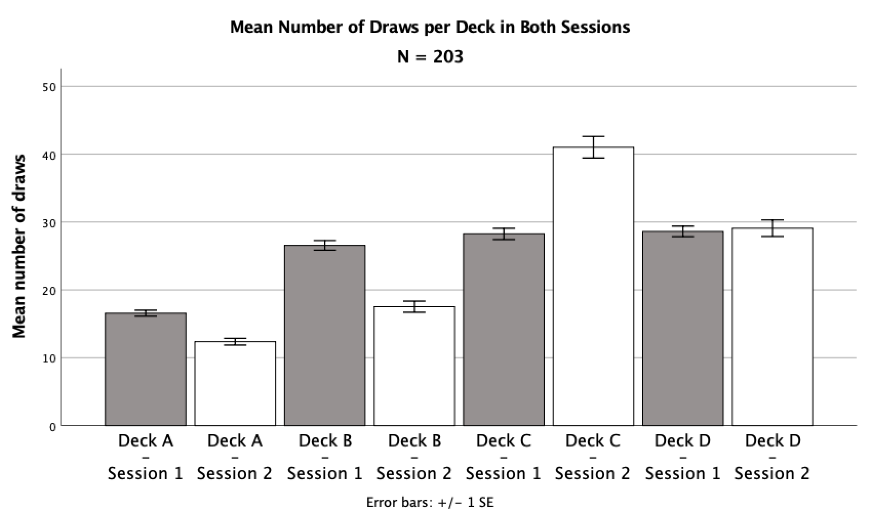

Figure 1: Mean number of draws per deck in both sessions for entire sample.

This indicates that non-profitable decks (A and B) were generally chosen less than profitable decks (C and D). Further, this tendency appears to be stronger for session 2 than for session 1.

A repeated measures ANOVA showed a significant main effect of deck on number of draws, *F*(1.96, 396.68) = 94.38, *p* < .001, $η_{p}^{2}$ = .32 (Huyhn-Feldt corrected), and a significant interaction between session and deck, *F*(1.94, 392.26) = 61.94, *p* < .001, $η_{p}^{2}$ = .24 (Huyhn-Feldt corrected).

This means that some decks (C and D, Figure 1) are chosen significantly more than others, indicating that participants learn which decks are profitable. The interaction shows that distribution of draws varies between the two sessions, suggesting that participants likely applied a certain strategy in session 2 (Figure 1) based on what they had learned in session 1.

Paired samples *t*-tests were conducted to test for significant differences between number of draws from profitable (A and B) and non-profitable decks (C and D) in both sessions, and to test whether end capital was significantly different in the two sessions. The results are shown in Table 1.

|  |  |  |  |  |  |  |  |  |  |  |  |  |  |  |
| --- | --- | --- | --- | --- | --- | --- | --- | --- | --- | --- | --- | --- | --- | --- |
| Table 1:  *Mean share of draws from piles A&B vs C&D, and end capital* | | | | | | | | | | | | | | |
|  |  | *M* |  | *SD* |  | *M* |  | *SD* |  | *t*-tests | | | | |
|  |  | Decks A & B | | |  | Decks C & D | | |  | *t*(202) |  | *p* |  | *d* |
| Session 1 |  | 0.43 |  | (0.13) |  | 0.57 |  | (0.13) |  | 7.33 |  | < .001 |  | -1.03 |
| Session 2 |  | 0.30 |  | (0.16) |  | 0.70 |  | (0.16) |  | 17.99 |  | < .001 |  | -2.53 |
|  | | | | | | | | | | | | | | |
|  |  | Session 1 | | |  | Session 2 | | |  | *t*(202) |  | *p* |  | *d* |
| End capital |  | 1999.88 |  | 866.07 |  | 2956.65 |  | 1291.11 |  | 9.89 |  | < .001 |  | -0.89 |
| *Note: Values for deck-variables are displayed as mean share of draws from the respective decks; End capital displays capital measured in DKK at the end of session.* | | | | | | | | | | | | | | |

Results show that participants preferred the profitable decks over the non-profitable decks in both sessions, and this difference is greater for session 2 than session 1 (Table 1). Further, end capital is significantly greater for session 2 than for session 1. Results thus suggest that participants have learned which decks are profitable and apply strategies to obtain greater end capitals.

## **Participants earn money in session 2**

Drawing cards randomly from the various decks should result in an end capital similar to the start capital, whereas a strategy based on learning should result in an increased end capital.

A one-sample *t*-test (two-tailed, α = .05) showed a significant difference from 2000 DKK in end capital (*M* = 2956.65, *SD* = 1291.11) for session 2, *t*(202) = 10.56, *p* < .001, *d* = 0.74, but no such difference in end capital (*M* = 1999.88, *SD* = 866.07) for session 1, *t*(202) = -0.002, *p* = .998, *d* = 0.00.

This supports the hypothesis that participants learned which decks were profitable during session 1 and employed a specific strategy in session 2.

Figure 2 and 3 show capital and deck choices by number of draws for FP19201 for sessions 1 and 2 respectively. Figure 2 shows that FP19201 initially tested all decks, obtaining some major losses, and then applying a certain strategy. Figure 3 shows how FP19201 stuck with that strategy consistently during session 2, gaining an increased end capital. These choices are consistent with overall results.

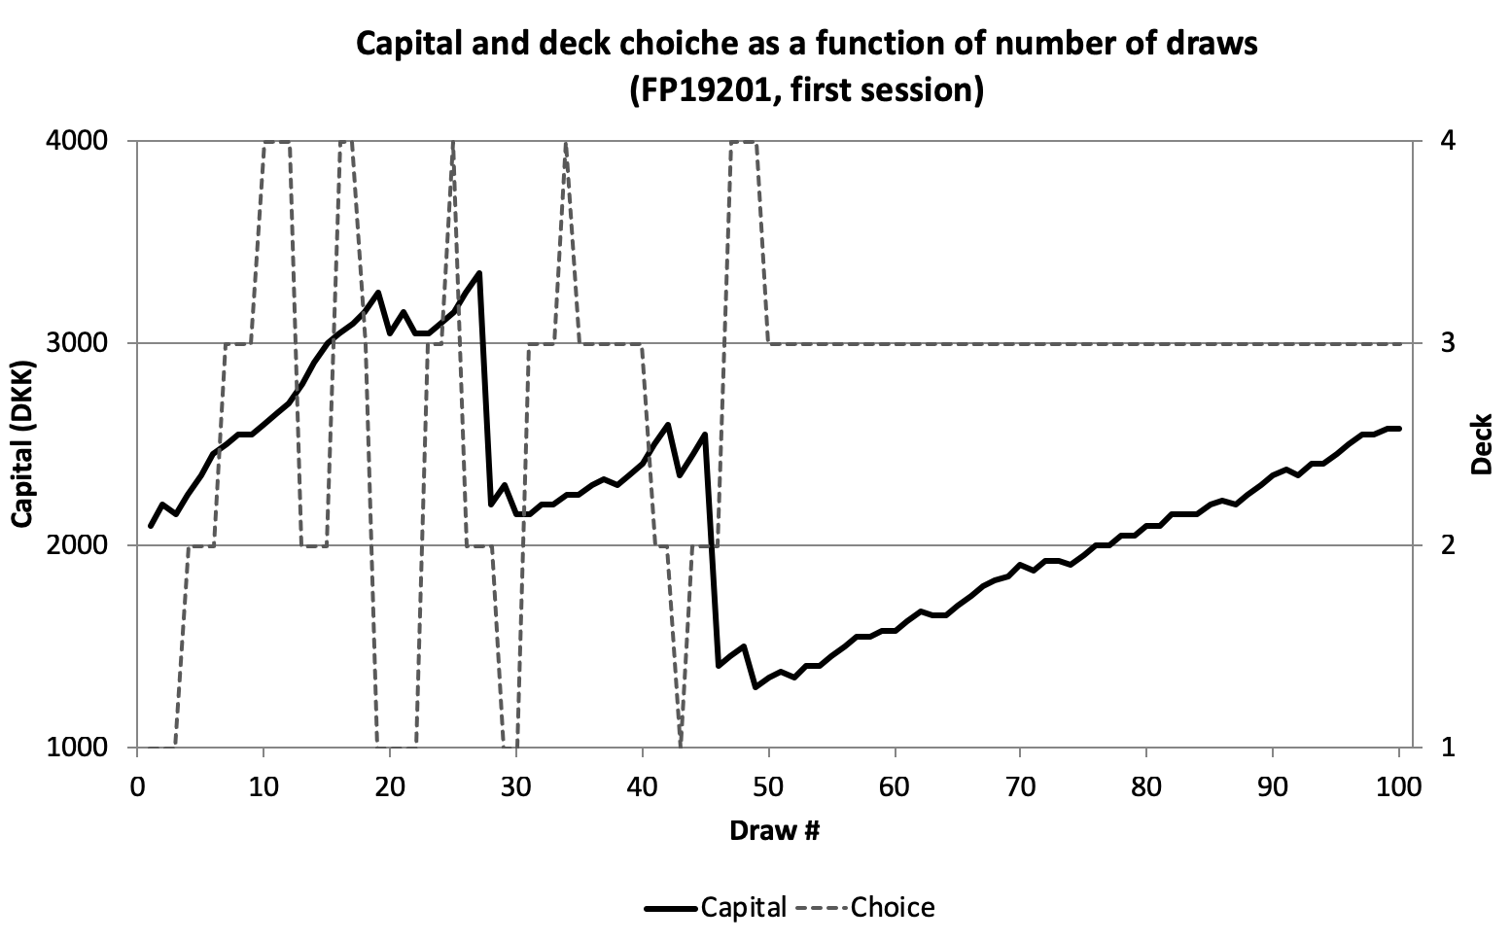

Figure 2: Profile of card selection and overall capital for session 1 for FP19201.

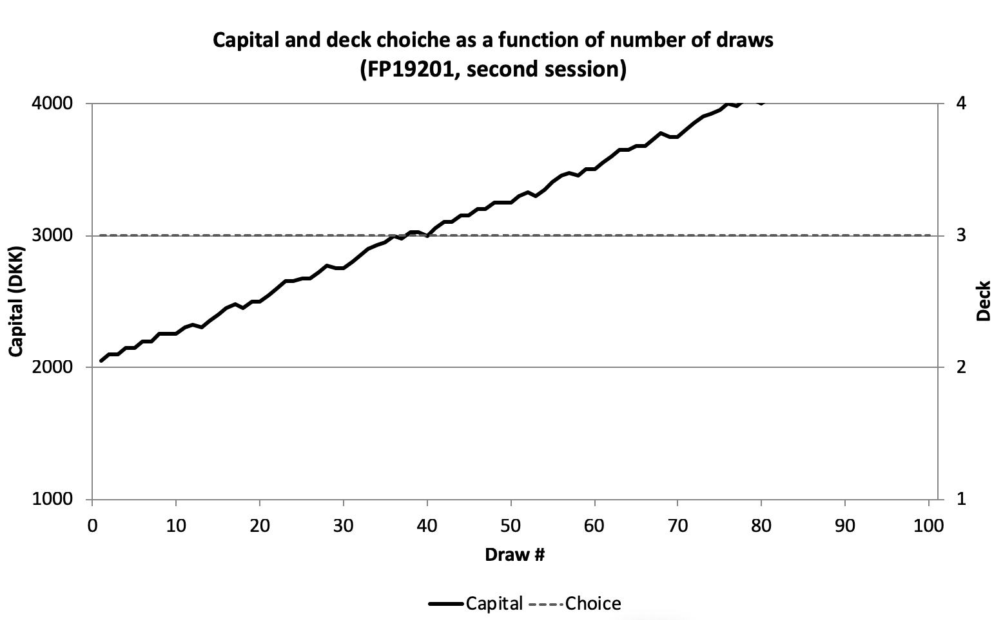

Figure 3: Profile of card selection and overall capital for session 2 for FP19202.

## **Some people learn faster than others**

A two-tailed Pearson’s correlation showed a significant positive correlation between end capital for session 1 and end capital for session 2, *r*(201) = .23, *p* < .001.

This means that participants that earned the greatest end capitals in the first session also had the greatest end capitals in the second session. Thus, some participants likely learned which decks were profitable faster than others, and hence were able to apply a profitable strategy earlier.

## **Age and end capital are not correlated**

If older people are inclined to take fewer risks than younger ones, then older participants should have a greater end capital than younger ones in session 2, as non-profitable decks involved the greatest risks.

A two-tailed Pearson’s correlation showed no significant correlation between age and end capital for session 2, *r*(201) = .04, *p* = .60.

Thus, the data do not support this hypothesis. However, it should be noted that the age distribution in the sample was fairly homogenous.

# **Conclusion**

These results provide evidence that people are able to make relatively accurate decisions based on insufficient knowledge.

# **Literature**

Bechara, A., Damasio, A. R., Damasio, H., Anderson, S. W. (1994). Insensitivity to future conse-

quences following damage to human prefrontal cortex. *Cognition*, *50*, pp. 7-15.

Dunn, B. D., Galton, H. C., Morgan, R., Evans, D., Oliver, C., Meyer, M., ... & Dalgleish, T.

(2010). Listening to Your Heart: How Interoception Shapes Emotion Experience and Intui-

tive Decision Making. *Psychological Science*, *21*(12), 1835-1844.

Purves, D., Cabeza, R., Huettel, S. A., LaBar, K. S., Platt, M. L., & Woldorff, M. G.

(2013). *Principles of Cognitive Neuroscience*. (2. udg.). Sunderland.